BOGUE BANKS
WATER NEWS

We hope you’ve all had a pleasant winter and are looking forward to another busy summer season here on the beach! With the summer crowds and the warmer temperatures comes increased water usage and a threat of hurricanes.

Irrigation During peak months
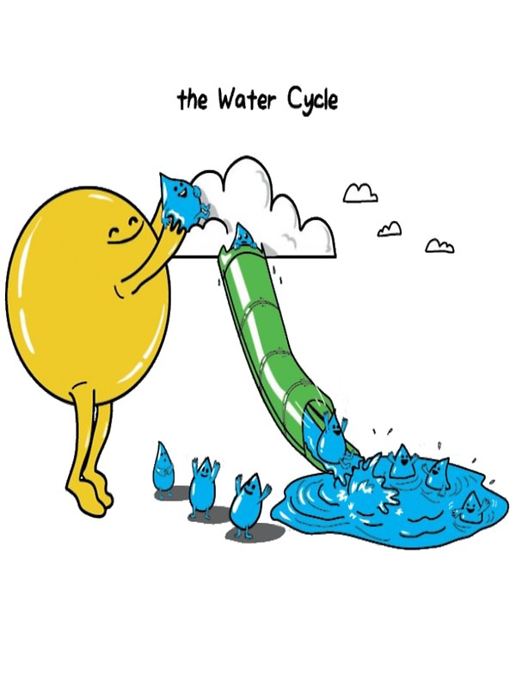
A vibrant green lawn is often a staple of warm weather and relaxing days outside. However, it can take a large amount of water to maintain these lawns, and drinking water is an extremely limited resource. Please keep this in mind when designing your new home, or redesigning your existing yard. A recent survey of homes with irrigation meters showed that the average home uses 76% of their water on the lawn. Roughly 1 in 6 homes in the BBWC service area has an irrigation system using public water. We are asking everyone using BBWC water for irrigation to turn-off their irrigation systems during the weekends. Saturday and Sunday are always our peak production days, often times increasing by upwards of 1 million gallons per day. By not irrigating your lawns during these 2 days, we can significantly cut back that increase on the weekends to help offset the increased number of users those days. This will result in less water being pumped out of the aquifer over time, will help keep it sustainable for a longer period of time, and may prevent the need for future irrigation use restrictions. Please help to conserve water by doing your part!

Hurricane Preparedness
The hurricane season is already upon us. NOAA has predicted a near or above normal season for the eastern seaboard with 5-9 hurricanes and 1-4 of them being classified as major. When making final preparations prior to storm impact, remember to turn off your water at the customer valve (green box) before leaving the island. If you are not leaving then make sure to know the location of your shut-off valve, that it works, and is easily accessible in an emergency. After the storm passes refrain from using water to wash off your house, driveway, etc. There are usually dozens, if not hundreds of small to medium sized leaks. The leaks add up in volume and it can be a struggle on the system to provide enough water to keep the lines pressurized. BBWC will issue a ‘Resume normal use’ bulletin on our website once most leaks are identified.

Backflow Prevention Program Update
We are making great progress, thanks to the hard work of our Backflow Inspector, Shaun Toms, and his assistant, Sharon Guthrie. Many thanks and appreciation to them, and to those of you who have responded to the certified letters we have sent out regarding your specific need for one of these devices. If you have not received a certified letter, you do not need to be concerned with installing a backflow prevention device. We continue to send out certified letters to those homeowners whose property(s) contains a moderate or severe hazard (see our policy for more information on this) and have not yet installed a backflow prevention device. If you receive one of these letters, we appreciate your prompt response. While it is not required to purchase from us, we do offer the backflow prevention device and cover at our cost. We realize this is a costly venture, and we do this to help offset some of your expenses. While we do not recommend any plumber over another, we do keep a list of area plumbers available on our website or in the office. Thank you for being our valued customer! We appreciate each one of you, and your assistance in helping to protect our most cherished natural resource – WATER!

